Day 1:
JSON Server
React JS
JEST testing framework

JSON Server:

Before node JS, JavaScript was known as client side scripting language.
www.google.com --

Req (http/https)--
Client Server
--Res(http/https)
Html
Css
JS

Java + Spring boot
Asp.net
Php
Python + Django / Flask
Node JS
After node JS JavaScript also knows as server side programming language. Now a day using Node JS as well as JavaScript we can write the code client side scripting and server side scripting.
With help of node js we can run JavaScript code outside browser environment.
With help of client side JS we can’t do file handling program, we can’t store data in database. We can’t achieve security program etc. but with help of node JS we can achieve all these features.
Node js provided npm (node package manager). Npm is a tool which help to download external js modules. Node js provided lot of pre defined module which help to do different types of task.
Syntax to install node js third party modules

npm install modulename -g (global)
or
npm install modulename (locally)

json-server : json-server is a pre defined module provided by node js which help to makes static json file as dummy rest api.

npm install json-server -g install the module
json-server –version verify the module
json-server db.json this command help us to make json file as rest api
it run on default port number 3000
json-server rest api we can do the operation as store, delete, update and retrieve.
Once rest api ready with help of json-server using
JS or React JS we can store, delete, update and retrieve data.

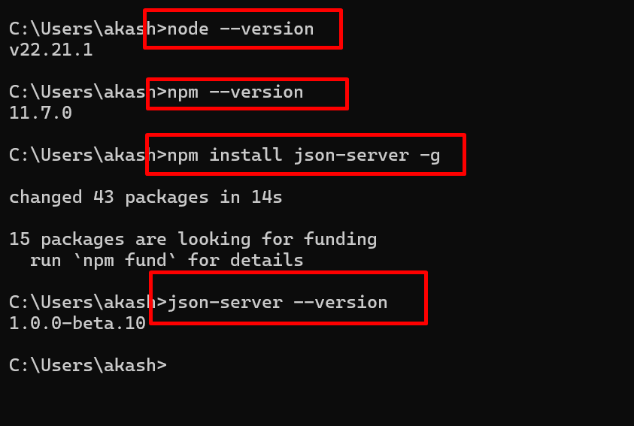

JS
Or JSON-Server
React JS
Client Side program Server Side

Filename.json

{
“products”:[
{},
{},
{},
],
“orders”:[
{},
{},
{}
]
}

json-server products.json
Or
npx json-server products.json

by default port number 3000

json-server products.json –-port 3001

Rest API provided http protocol methods.

Get : Get is use to get the resources like products, customer, orders, etc.
Search particular resource information using id property.
Post : create new resource like product, order, customer etc.
Store the data

Put/Patch : both are use to update the data using unique property ie id
Update existing resource
Put is use to update all property information except id property.
Patch is uses to update partially few property not all.
Delete : it is use to delete resource using unique property ie id.

To test REST API develop using json-server or server side technologies like java, python or node js
We need rest api plugin.
Post man client : Rest API (GUI) base plugin
CURL : command prompt non window command help us to test rest api.
Git bash terminal support curl

Once you login in post main client plugin.
You need to create workspace (directory or folder).

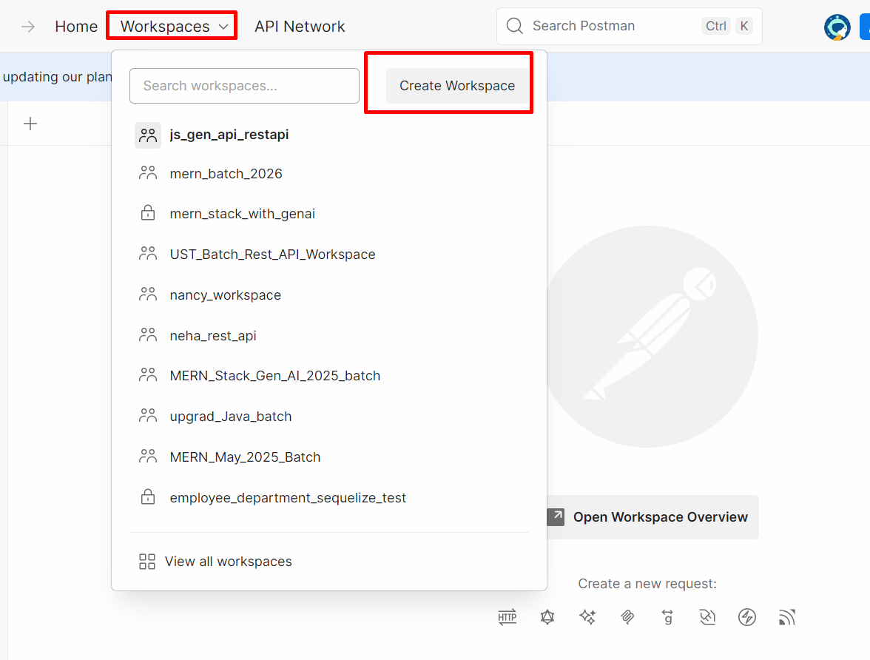
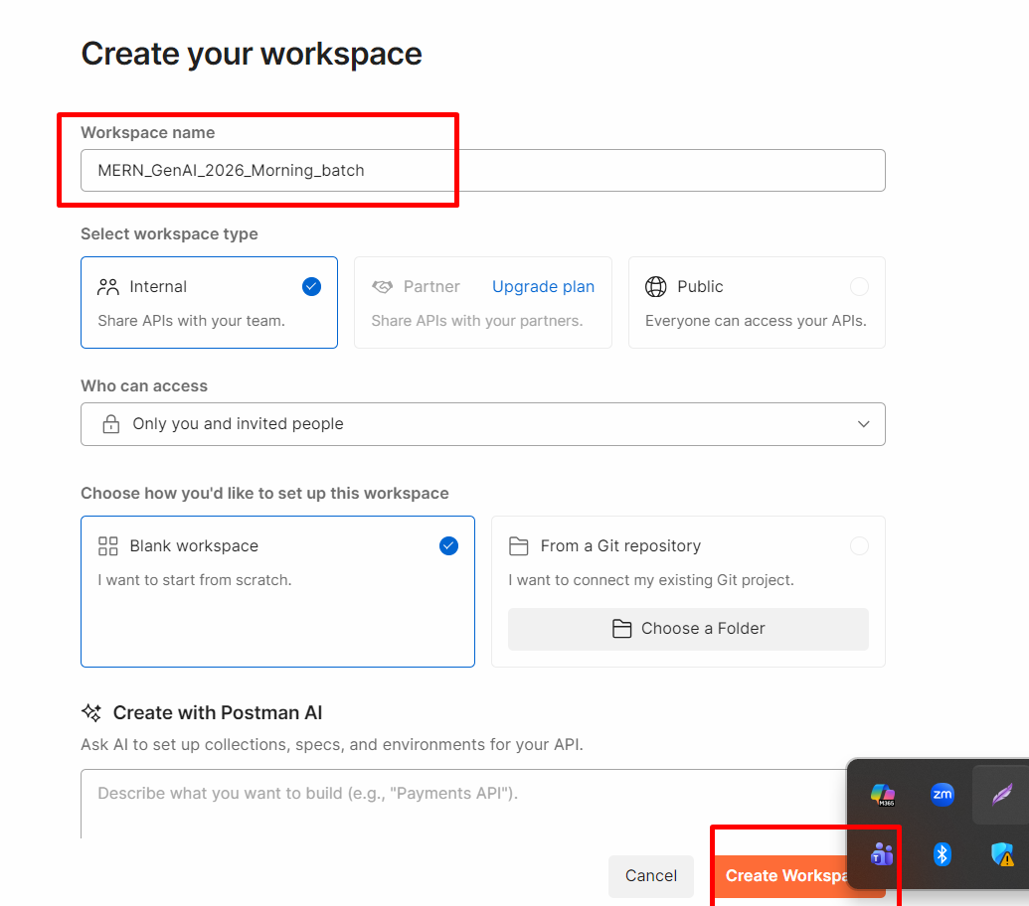

Inside one workspace we can create more than one collection.
Each collection can contains more than one end point URL.
Like get, post, put, patch and delete
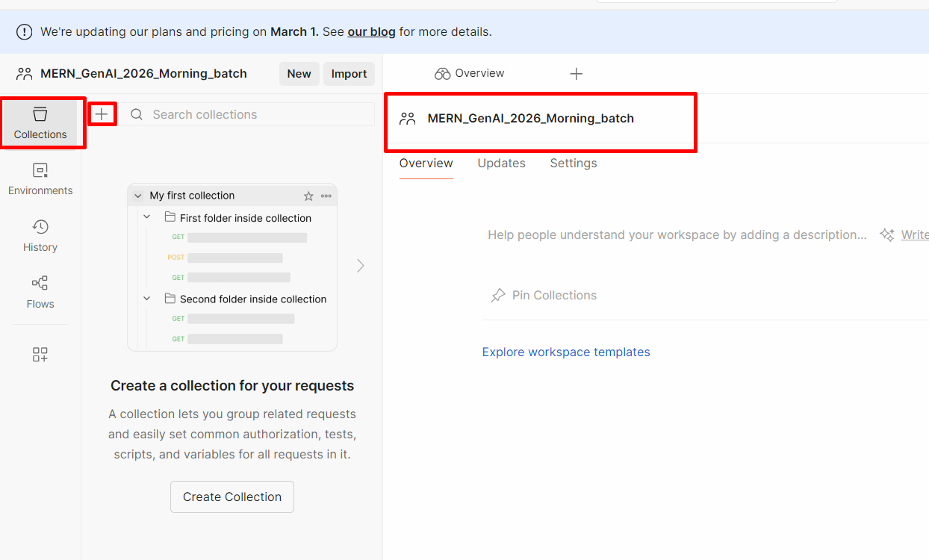

Select blank collection

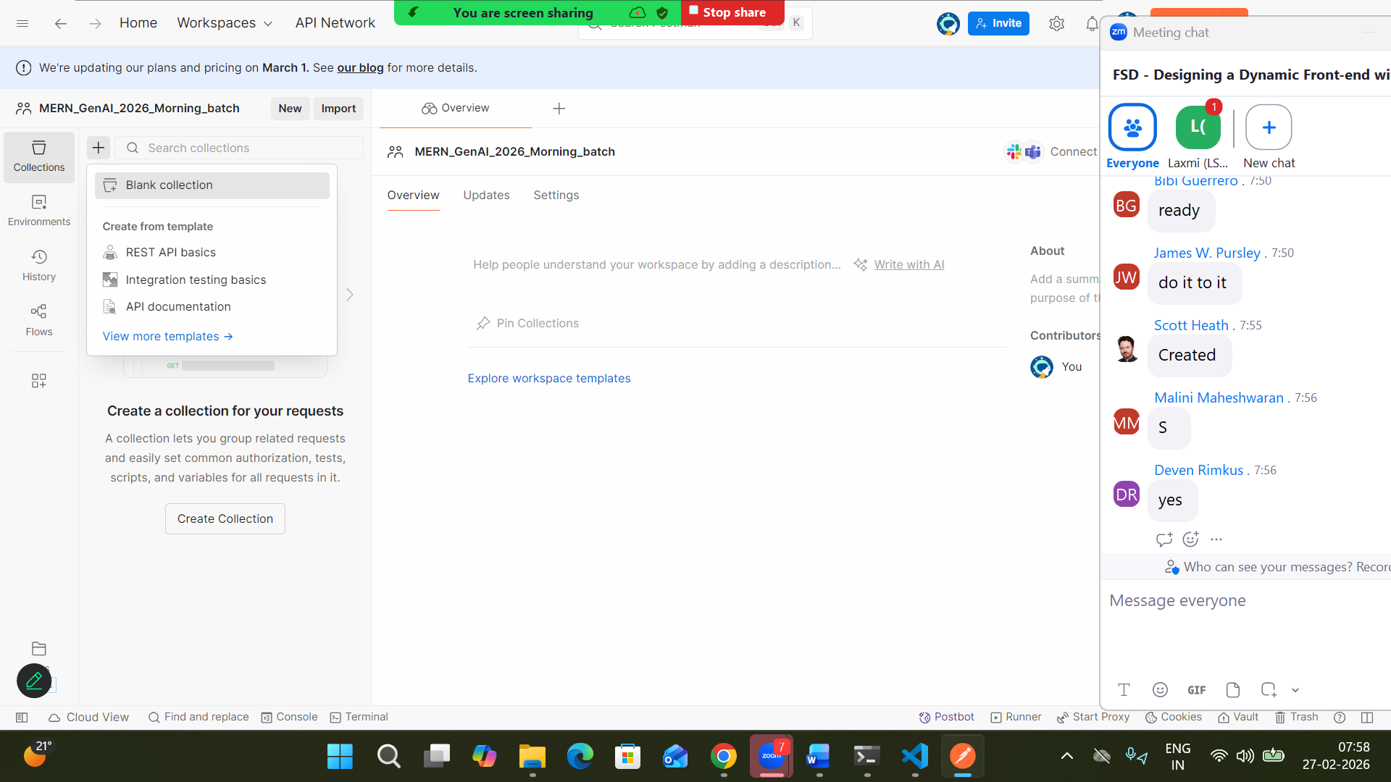

Inside once collection we can create any request end point

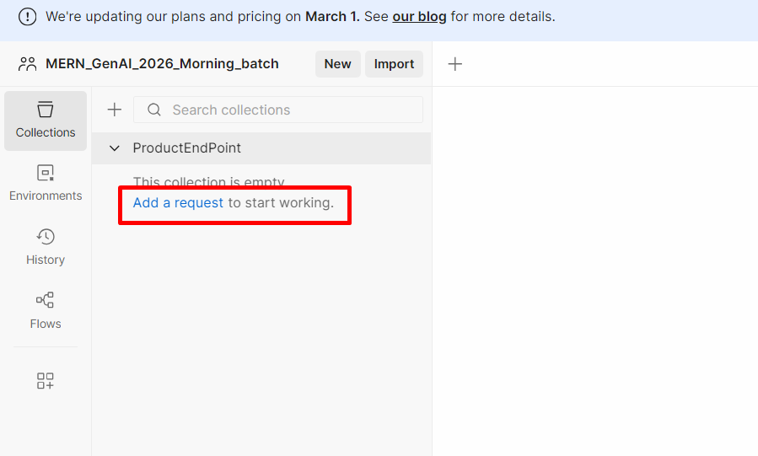

Testing Get method

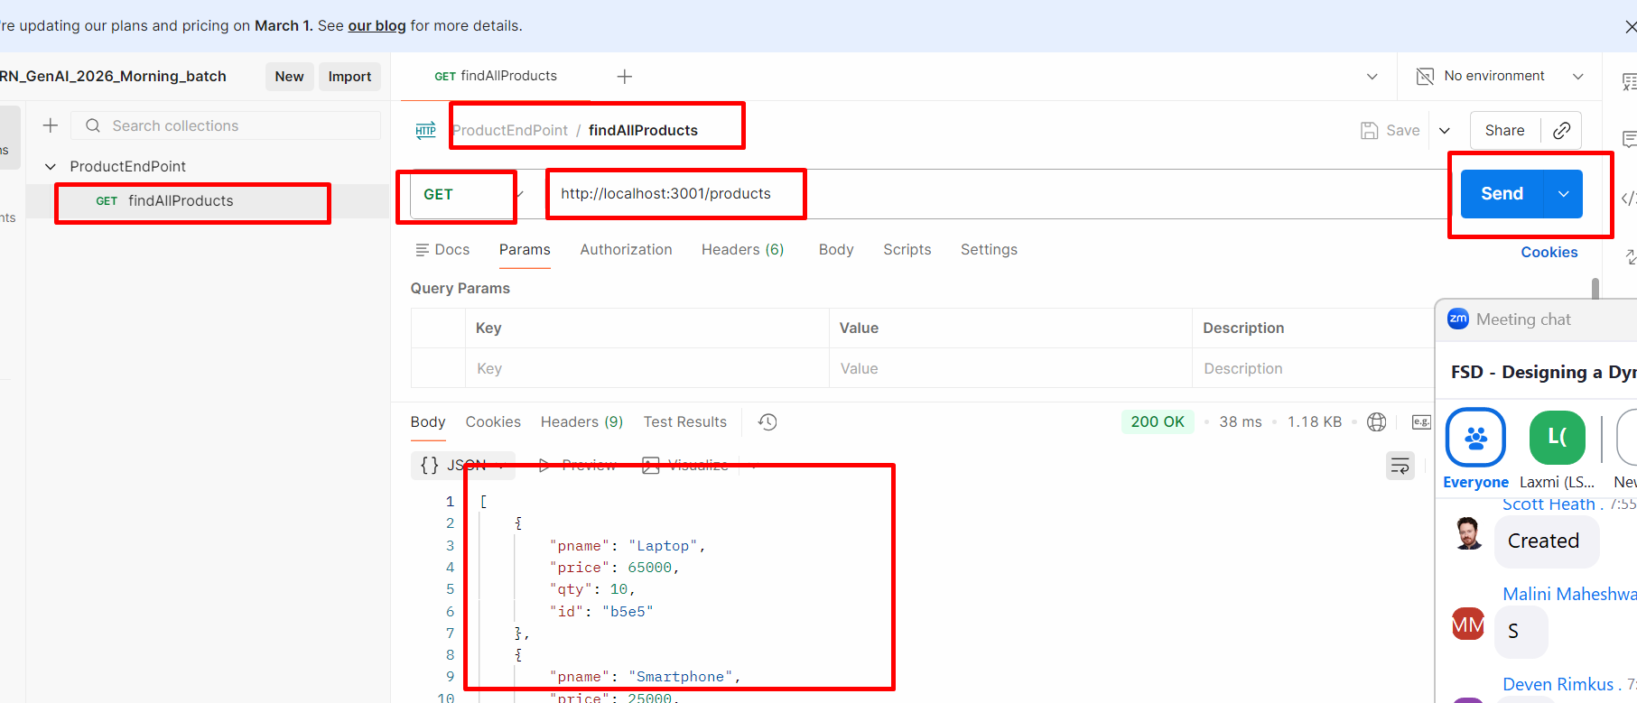

Search particular product using id.
We need to use path param technique
URL/idValue

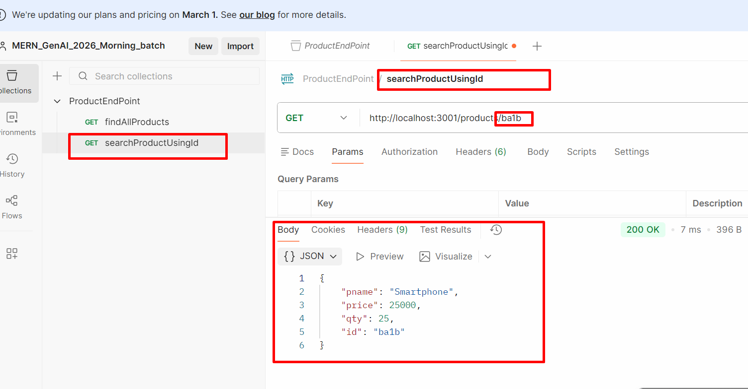

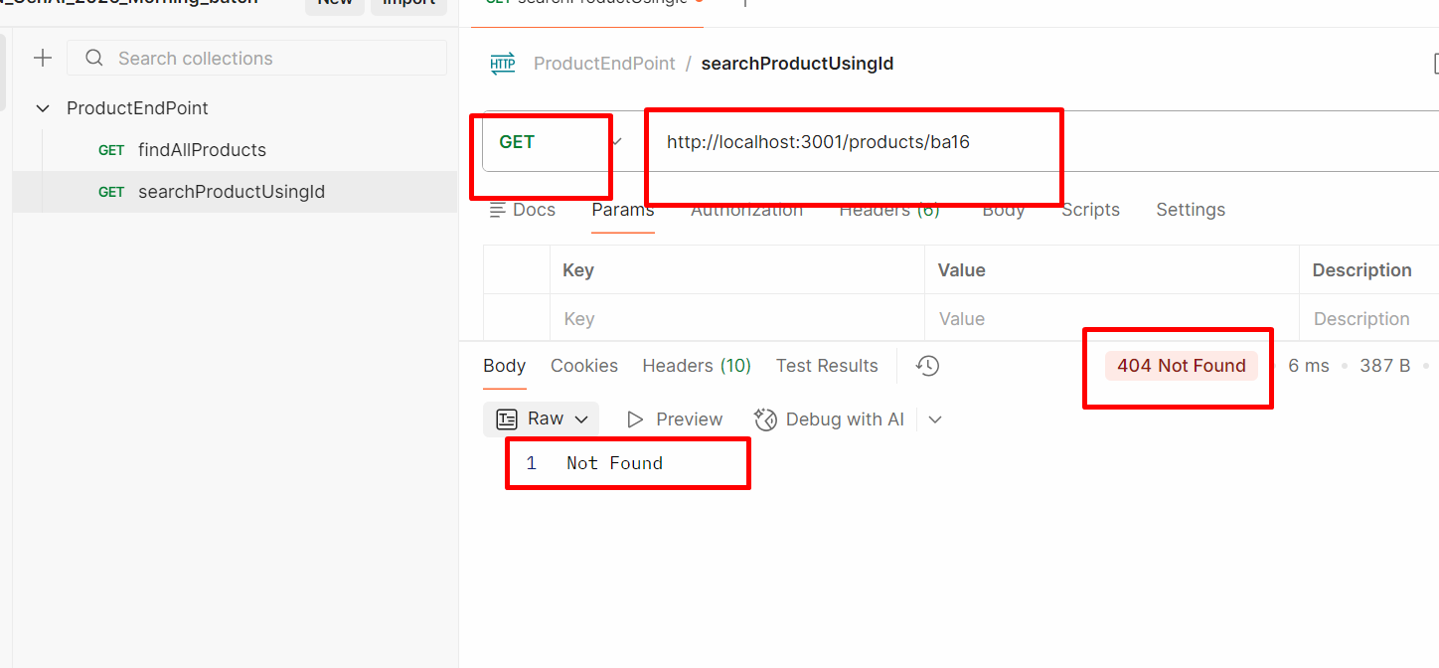

Store product

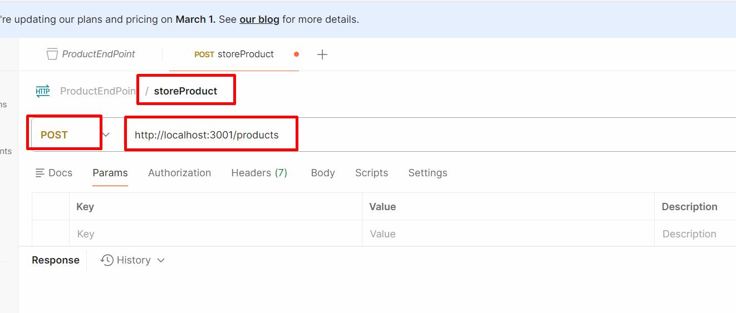

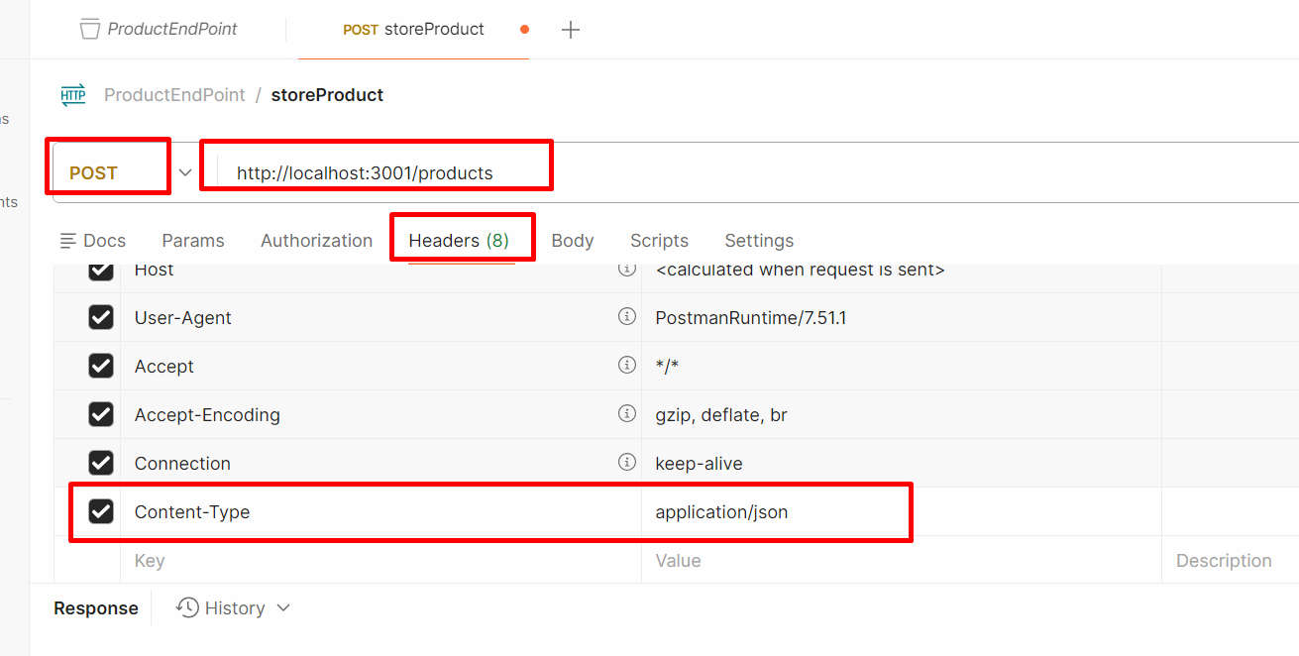

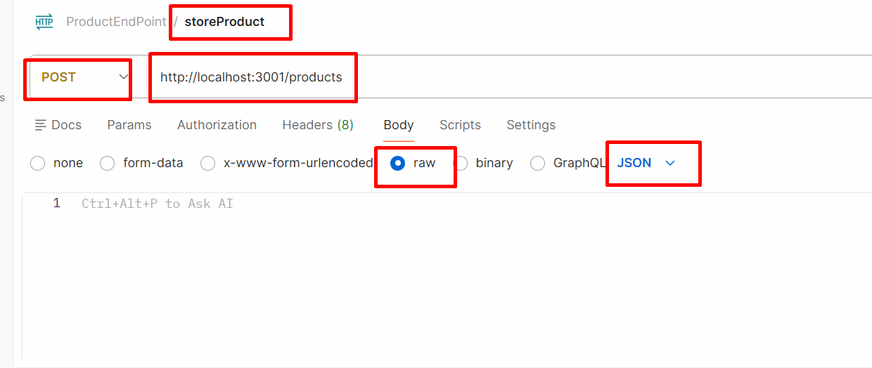
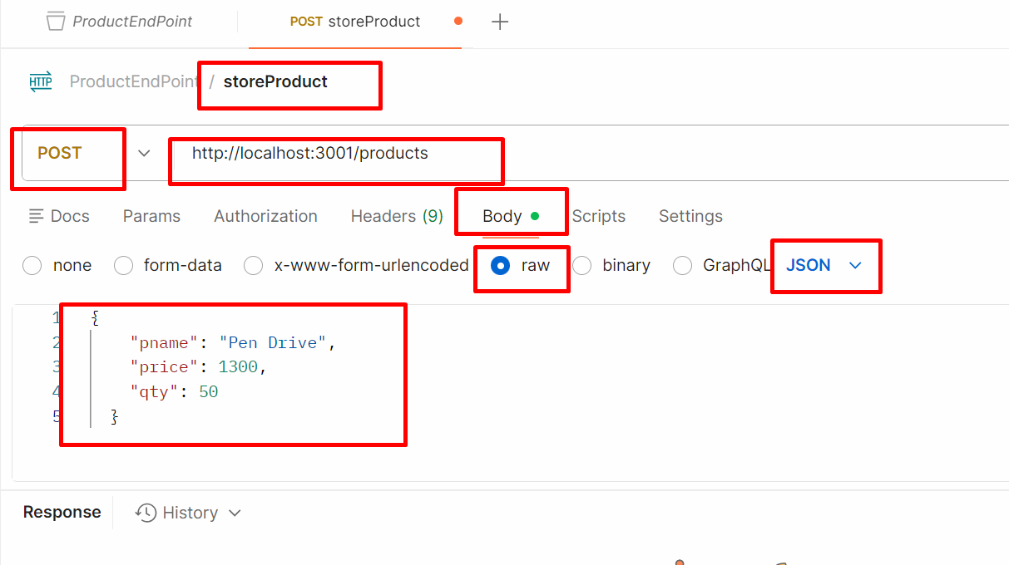
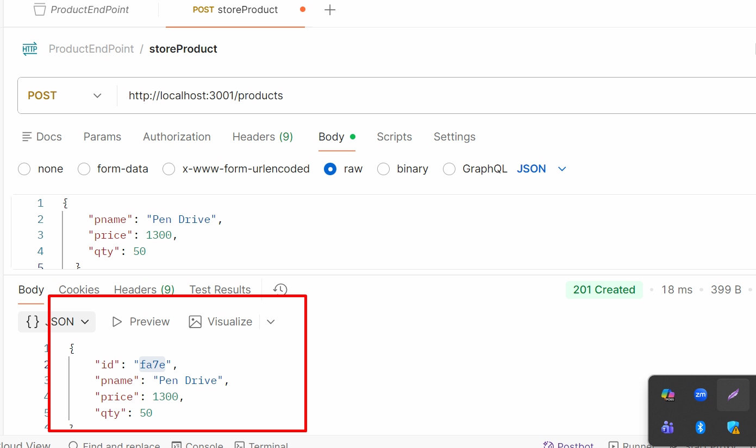

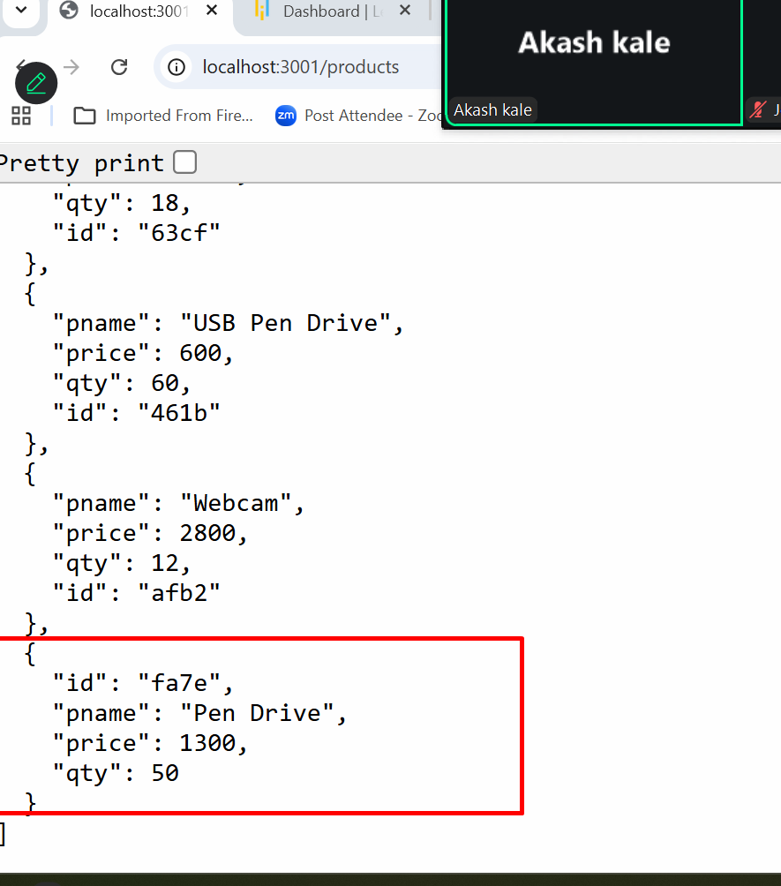

Updating product price using id

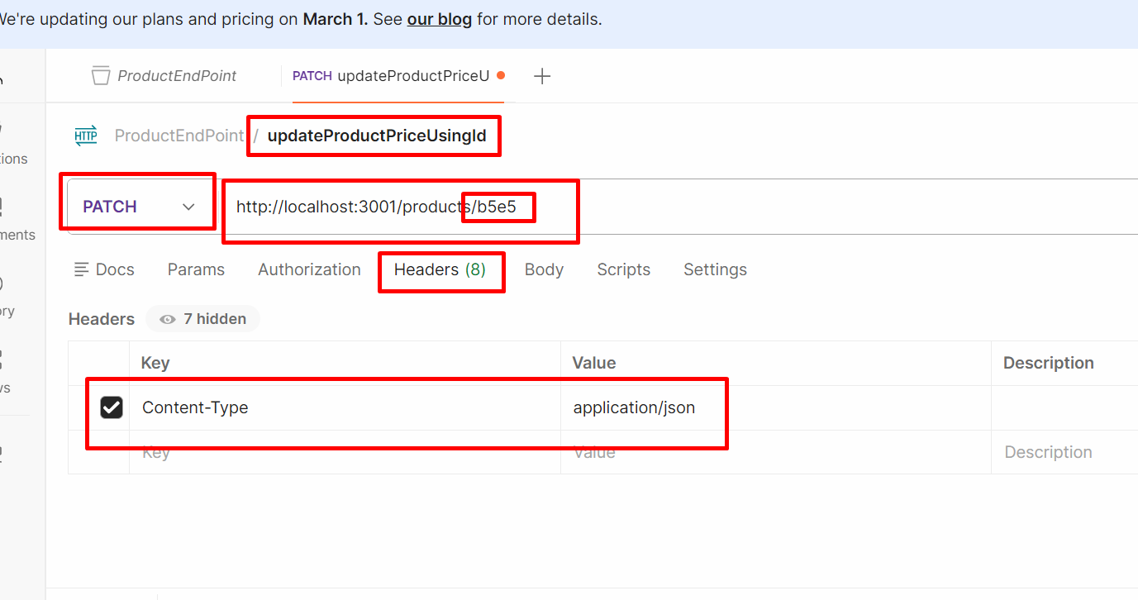
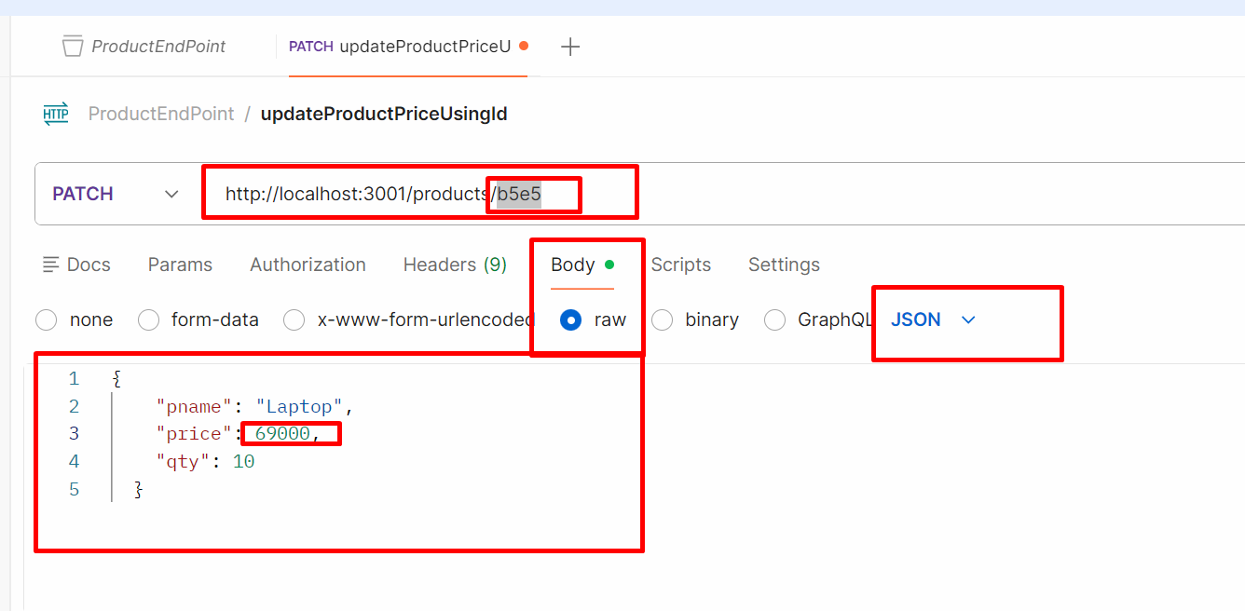

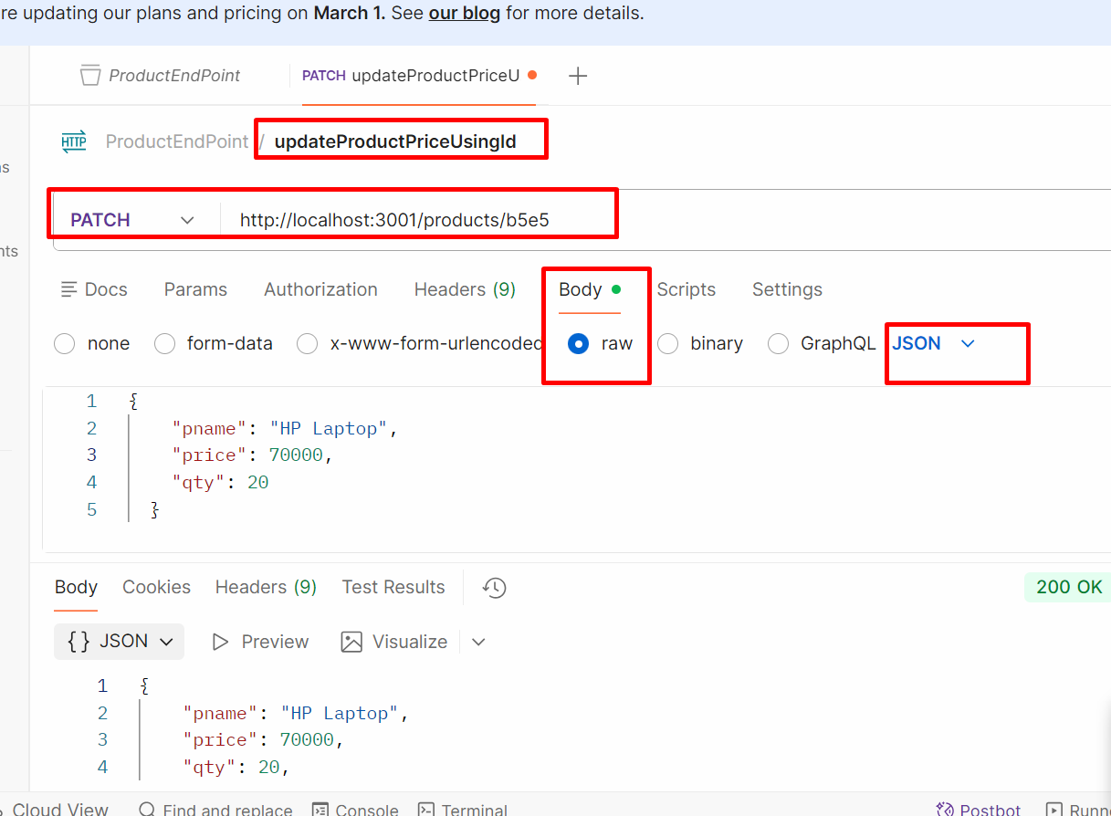

Delete the product using id

